High Level Design (HLD)

Grainger PLC
Void Management Process

Version 1.0
June 1, 2023
Contents
Table of Contents
1 overview 3
1.1 Introduction 3
2 salesforce strategy 4
2.1 org info 4
2.2 org strategy 4
2.3 document management 4
2.4 archival strategy 4
2.4.1 File Archival 5
2.4.2 Record Archival 5
2.4.3 Recommendation 6
2.5 Mobile strategy 6
2.6 reporting strategy 6
2.7 add-ons / appexchange apps 6
2.8 multi language / multi currency 6
2.9 additional user licenses 6
3 data model 7
3.1 entity relationship diagram 7
3.2 sharing and security 7
4 integrations 8
4.1 release 1 integration requirements 8
4.2 roadmap 8
5 data migration 9
5.1 release 1 data migration requirements 9

overview

Introduction
This document provides a high level design for the proposed Void Management solution to be implemented on Grainger PLC’s Salesforce org. The design is intended to establish the key architectural decisions that will underpin the solution and ensure that it adheres to the 3 key principles of the Salesforce Well-Architected Framework:

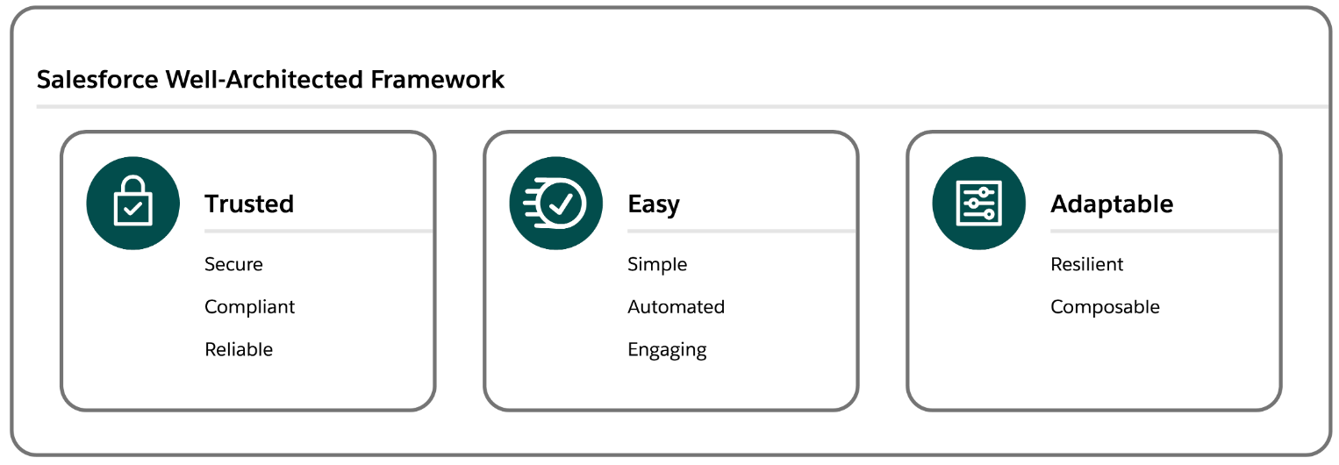

Trusted solutions protect stakeholders
Easy solutions deliver value fast
Adaptable solutions evolve with the business.

This design does not cover the lower level detail (e.g. fields, profiles, automations, validation rules) – these will be designed and documented at user story level during the agile implementation phase.

salesforce strategy

org info
The Grainger PLC Salesforce org was provisioned in October 2019. It is an Enterprise Edition org with single GBP currency. There are currently 210 Service Cloud licenses, 25 Platform licenses and 40 Partner Community licenses assigned to the org.

org strategy
At this point in time there are no requirements (e.g. data residency, large data volumes, autonomous business units etc.) that would require a multi-org strategy, thus the Void Management process will follow a single org strategy and will be implemented on the existing Grainger PLC Salesforce org. Among other benefits, a single org provides the best solution to easily deliver unified processes, a single view of the customer and lower total cost of ownership.

document management
It is understood that the current document management system (DocuShare) is being retired in June 2024, currently with no replacement having been identified. It is recommended that the Void Management Process make use of Salesforce Files to manage the various documents that are collected and collaborated on. Salesforce Files will allow documents to be attached in context to the records they relate to – e.g. photos of damage to paint work may be attached to a task being created to book maintenance work. This allows easy collaboration and sharing across the multiple teams that are involved in the Void Management Process.

archival strategy
Salesforce file and data storage capacity is limited and is determined by a base allocation at org level plus a per-user allocation. Any overage will require the purchase of additional storage from Salesforce. Additionally for data (i.e. records rather than files), a high number of records of any one object can result in large data volume (LDV) performance limitations (report timeouts, slow page loads etc.). Thus it is desirable to operate within the allocated capacity if possible and implement an archival strategy to move data and files off-platform at a point in time where users no longer need to interact with them.
In order to calculate data and file volumes, the following assumptions have been used:
- Number of units: 13 000 in year 1, scaling to ±30 000 in year 5
- Number of voids per year: 1 void per unit
- Number of tasks per void: 40
- Number of files per void: 10
- Average file size: 2MB
Based on these assumptions, the table below shows predicted data and file storage requirements.
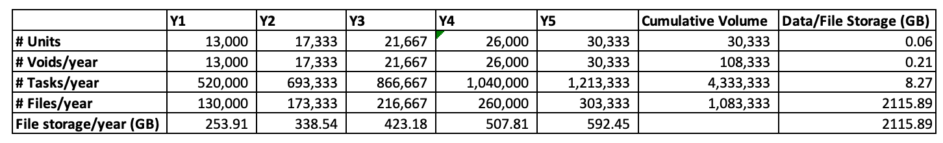
Table 1 Projected File and Data Storage

File Archival
Grainger PLC’s Salesforce org currently has a 503GB file storage limit, of which 66GB is already used. Based on the projected volumes above, this limit would be exceeded in the second year of operation. While not required for the go-live of the Void Management solution, it is suggested that an archival policy be considered so that files can be automatically moved (e.g. via GREP) from Salesforce to a more cost effective storage solution (e.g. SharePoint). Files should be archived at a point in time where users no longer need to interact with them directly from Salesforce, for example 6 months after a void has been completed. File-specific policies may also be implemented, for example the inventory pdf may be retained on the Salesforce platform for longer than photos of painting works.

Record Archival
Grainger PLC’s Salesforce org currently has a 14.8GB data storage limit, of which 7.5GB is already used. Based on the projected volumes above, the data storage limit is likely to be exceeded within the next 5 years. While not required for the go-live of the Void Management solution, it is suggested that an archival policy be considered so that records can be automatically moved (e.g. via GREP) from Salesforce to a more cost effective storage solution (e.g. Azure SQL). Records should be archived (or deleted) at a point in time where users no longer need to interact with them directly from Salesforce, for example 6 months after a void has been completed. Object-specific policies may also be implemented, for example Void records may be retained on the Salesforce platform for longer than the tasks that relate to the void.

Recommendation
There is no need for the immediate implementation of any archival strategy. Given that the above calculations are based on assumptions, it is recommended that volumes be monitored during the course of operations. Based on actual record volumes a suitable archive strategy and timelines can be planned.

Mobile strategy
It is recommended that the Salesforce Mobile App be used to provide mobile access where required. There are no offline, branding or native device capability requirements that would necessitate any custom mobile app development.

reporting strategy
Operational reporting needs can be met via Salesforce reports. Should deeper analytical capabilities be required in the future, these can be met via a BI solution such as Power BI coupled with an Azure SQL data warehouse.

add-ons / appexchange apps
No additional add-ons or AppExchange apps are required for this solution.

multi language / multi currency
Multi language and multi currency are not required for this solution.

additional user licenses
It is understood that all users who will be part of the first release of the Void Management solution have already been provisioned with full Salesforce licenses. There is thus no requirement to purchase any additional licenses.
Future functionality may involve additional users (e.g. external contractors to be assigned inspection tasks), in which case requirements would need to be evaluated to determine the most suitable license types (e.g. customer community vs. customer community plus).

data model

entity relationship diagram
The Void Management solution data model is shown below with existing standard and custom objects as already implemented in the Grainger PLC Salesforce.
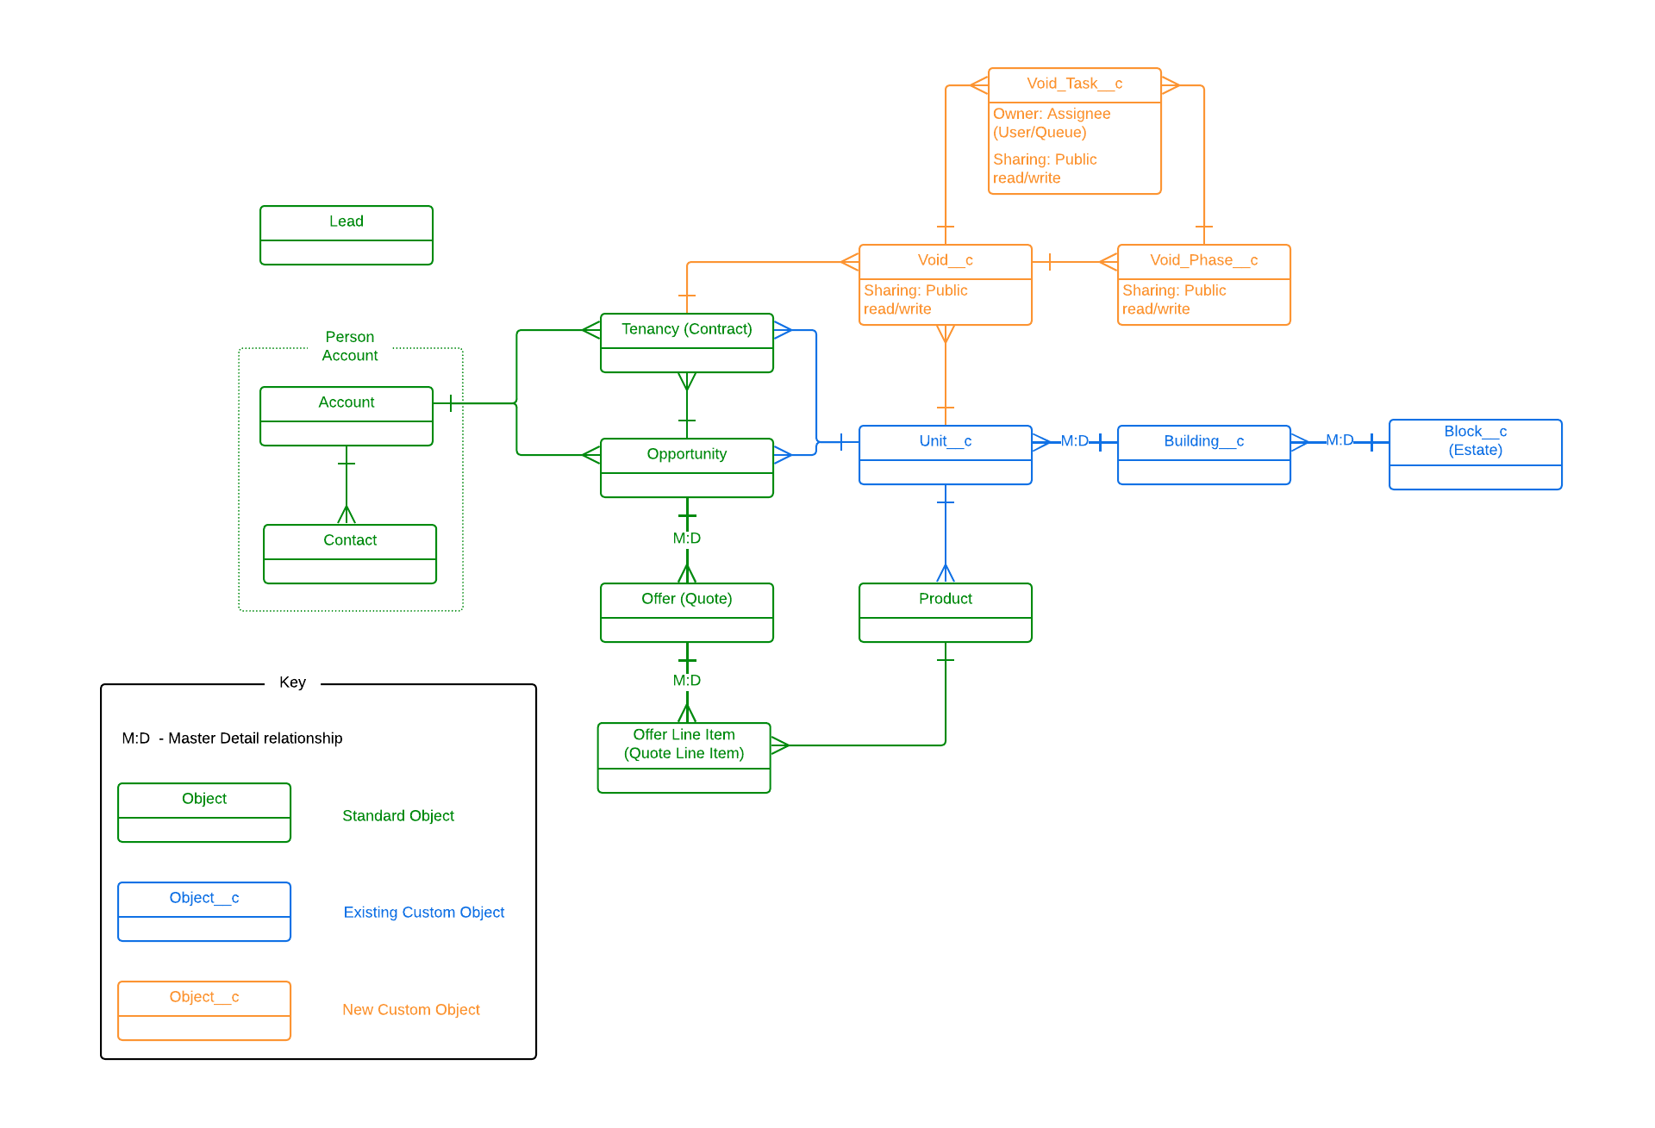
Table 2 Entity Relationship Diagram

sharing and security
The Grainger PLC Salesforce org currently has a public read/write org wide default (OWD) for all key objects (Account, Opportunity, Tenancy) and allows all users to view all records. Where no security requirements exist to restrict visibility, this solution provides full visibility to all users and facilitates easy collaboration (e.g. users are able to update tasks belonging to a colleague when the colleague is absent). Based on this, it is proposed that the Void Management objects will follow the same OWD and allow full access to all users. Should future requirements necessitate a tighter security model, this can be implemented with the many security mechanisms provided by Salesforce (role hierarchy, sharing rules etc.).

integrations

release 1 integration requirements
Functionality proposed for release 1 does not require any new integrations between Salesforce and other applications. Release 1 focuses on implementing the void management process within Salesforce, using tasks to track off platform activities (e.g. users will cancel a direct debit in the finance system and mark the Salesforce task as completed).
Existing integrations (e.g. Qube / Salesforce property master data) will be leveraged to ensure the Void Management process aligns with the overarching goal of providing a single view of the customer and property.

roadmap
Future releases will include integrations to FSI, Qube, Hive and the Grainger Portal (and other systems as identified). Where possible, all integrations should be implemented via the GREP integration layer to:
- ensure a decoupled architecture
- take care of routing and error handling
- fall under existing Grainger standard operating procedures (SOP)
- support complex transformations
- efficiently handle large data volumes
It is understood that various integration initiatives are already in progress (e.g. automated lease creation in Qube triggered by Tenancy in Salesforce). The Open Box implementation team should work closely with Grainger PLC to ensure the roadmap is aligned and supports the Void Management road map.

data migration

release 1 data migration requirements
The current state Void Management process is largely manual. There is no source of void data that could be feasibly migrated to Salesforce. As the Salesforce Void Management solution goes live, users will start using it to create new voids. Any in progress voids should be completed using the current manual process.
It is assumed that the existing Salesforce customer and property data is of a sufficiently high quality to support the Void Management process. No cleansing, enriching or de-duplication is planned.

